# VISVESVARAYA TECHNOLOGICAL UNIVERSITY

## “JnanaSangama”, Belgaum -590014, Karnataka.



**LAB REPORT**

**on COMPILER DESIGN**

*Submitted by*

**Akram (1BM21CS013)**

***Under the Guidance of***

**Lohith JJ**

**Assistant Professor, BMSCE**

*in partial fulfilment for the award of the degree of*

**BACHELOR OF ENGINEERING**

in

**COMPUTER SCIENCE AND ENGINEERING**



**B.M.S. COLLEGE OF ENGINEERING**

**(Autonomous Institution under VTU)**

**BENGALURU-560019**

**November 2023-February 2024**

**B. M. S. College of Engineering,**

**Bull Temple Road, Bangalore 560019**

**(Affiliated To Visvesvaraya Technological University, Belgaum) Department of Computer Science and Engineering**



**CERTIFICATE**

This is to certify that the Lab work entitled “**Compiler Design**” carried out by **AKRAM (1BM21CS013)** , who is bonafide student of **B. M. S. College of Engineering.** It is in partial fulfilment for the award of **Bachelor of Engineering in Computer Science and Engineering** of the Visvesvaraya Technological University, Belgaum during the year 2023-24.

The Lab report has been approved as it satisfies the academic requirements in respect of **Compiler Design- (22CS5PCCPD)** work prescribed for the said degree.

## Lohith JJ Dr. Jyothi Nayak

Assistant professor Professor and Head

## Department of CSE Department of CSE

BMSCE, Bengaluru BMSCE, Bengaluru

# B. M. S. COLLEGE OF ENGINEERING

**DEPARTMENT OF COMPUTER SCIENCE AND ENGINEERING**



***DECLARATION***

## I, Akram (1BM21CS013), student of 5th Semester, B.E, Department of Computer Science and Engineering, B. M. S. College of Engineering, Bangalore, hereby declare that, this lab report entitled "**Compiler Design**" has been carried out by me under the guidance of Prof. Lohith JJ, Assistant Professor, Department of CSE, B. M. S. College of Engineering, Bangalore during the academic semester November-2023-February-2024.

I also declare that to the best of my knowledge and belief, the development reported here is not from part of any other report by any other students.

# TABLE OF CONTENTS

|  |  |  |
| --- | --- | --- |
| **Sl. No** | **Title** | **Page No** |
| **1** |  | **6-8** |
| 1.1 | Write a program in LEX to recognize different tokens: Keywords, Identifiers, Constants, Operators and Punctuation symbols**.** | 6 |
| 1.2 | Write a program in LEX to count the number of characters and digits in a string. | 7 |
| 1.3 | Write a program in LEX to count the number of vowels and consonants in a string. | 8 |
| **2** |  | **9-15** |
| 2.1 | Write a program in lex to count the number of words in a sentence. | 9 |
| 2.2 | Write a program in lex to demonstrate regular definition. | 10 |
| 2.3 | Write a program in lex to identify tokens in a program by taking input from a file and printing the output on the terminal. | 11-12 |
| 2.4 | Write a program in lex to identify tokens in a program by taking input from a file and printing the output in another file. | 13-14 |
| 2.5 | Write a program in lex to find the length of the input string. | 15 |
| **3** |  | **16-23** |
| 3.1 | Write a program in LEX to recognize Floating Point Numbers. | 16 |
| 3.2 | Read and input sentence, and check if it is compound or simple. If a sentence has the word- and , or ,but ,because ,if ,then ,nevertheless then it is compound else it is simple. | 17 |
| 3.3 | Write a program to check if the input sentence ends with any of the following punctuation marks ( ? , fullstop , ! ) | 18-19 |
| 3.4 | Write a program to read an input sentence and to check if the sentence begins with  English articles (A, a,AN,An,THE and The). | 20-21 |
| 3.5 | Lex program to count the number of comment lines (multi line comments or single line) in a program. Read the input from a file called input.txt and print the count in a file called output.txt. | 22 |
| 3.6 | Write a program to read and check if the user entered number is signed or unsigned using appropriate meta character. | 23 |
| **4** |  | **24-36** |
| 4.1 | Write a LEX program that copies a file, replacing each nonempty sequence of white spaces by a single blank. | 24-25 |
| 4.2 | Write a LEX program to recognize the following tokens over the alphabets  {0,1,..,9} | 26-36 |

|  |  |  |
| --- | --- | --- |
| 4.2.1 | The set of all string ending in 00. | 26 |
| 4.2.2 | The set of all strings with three consecutive 222’s. | 27 |
| 4.2.3 | The set of all string such that every block of five consecutive symbols contains at least two 5’s. | 28-29 |
| 4.2.4 | The set of all strings beginning with a 1 which, interpreted as the binary representation of an integer, is congruent to zero modulo 5. | 30-31 |
| 4.2.5 | The set of all strings such that the 10th symbol from the right end is 1. | 32 |
| 4.2.6 | The set of all four digits numbers whose sum is 9. | 33-34 |
| 4.2.7 | The set of all four digital numbers, whose individual digits are in ascending order from left to right. | 35-36 |
| **5** |  | **37-38** |
| 5.1 | Write a C program to design lexical analysis to recognize any five keywords,  identifiers, numbers, operators and punctuations. | 37-38 |
| **6** |  | **39-40** |
| 6.1 | Write a program to perform recursive descent parsing on the following grammar:  S->cAd A->ab | a | 39-40 |
| **7** |  | **41-47** |
| 7.1 | Write a program in YACC to design a suitable grammar for evaluation of  arithmetic expression having +, -, * and /. | 41-42 |
| 7.2 | Write a program in YACC to recognize strings of the form {(a^n)b,n>=5}. | 43-44 |
| 7.3 | Write a program in YACC to generate a syntax tree for a given arithmetic  expression. | 45-47 |
| **8** |  | **48-49** |
| 8.1 | Write a program in YACC to convert infix to postfix expression. | 48-49 |
| **9** |  | **50-52** |
| 9.1 | Write a program in YACC to generate three address code for a given expression. | 50-52 |

**LAB 1**

* 1. **Write a program in LEX to recognize different tokens: Keywords, Identifiers, Constants, Operators and Punctuation symbols.**

**Code:**

%{

#include<stdio.h>

%}

%%

printf|for|void|main|while|do|switch|case|int|char|float|double|if|else {printf(“%s-keyword\n”,yytext);

, {printf("%s-separator\n",yytext);}

; {printf("%s-delimiter\n",yytext);}

[a-zA-Z_][a-zA-Z0-9_]* {printf("%s-Identifier\n",yytext);} ">"|"<"|">="|"<="|"==" {printf("%s- Relational operator\n",yytext);} "=" {printf("%s-assignment operator\n",yytext);}

[0-9]+ {printf("%s-digit\n",yytext);}

%%

void main()

{

printf("Give an input:\n"); yylex();

}

int yywrap()

{

return 1;

}

**Output:**

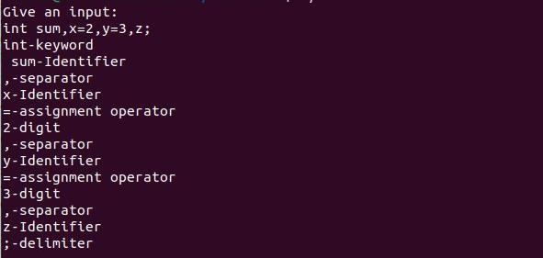

* 1. **Write a program in LEX to count the number of characters and digits in a string.**

**Code**

%{

#include<stdio.h> int d=0,c=0;

%}

%%

[a-zA-Z] {c++;}

[0-9] {d++;}

. ;

\n {printf("No of characters and digits are %d and %d\n",c,d),c=0,d=0;}

%%

void main()

{

printf("Enter a sentence:\n"); yylex();

}

int yywrap()

{

return 1;

}

**Output**

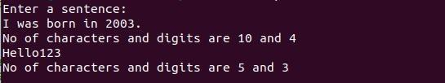

* 1. **Write a program in LEX to count the number of vowels and consonants in a string.**

**Code**

%{

#include<stdio.h> int v=0,c=0;

%}

%%

[AEIOUaeiou] {v++;} [A-Za-z] {c++;}

\n {printf("No of vowels and consonants are %d and %d\n",v,c),v=0,c=0;}

%%

void main()

{

printf("Enter a sentence:\n"); yylex();

}

int yywrap()

{

return 1;

}

**Output**

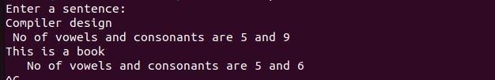

# Lab 2

* 1. **Write a program in lex to count the number of words in a sentence.**

**Code**

%{

#include<stdio.h> int words;

%}

%%

[^\t\n ]+ {words++;}

\n {printf("No of words in the sentence are %d.\n",words),words=0;}

%%

void main()

{

printf("Enter a sentence:\n"); yylex();

}

int yywrap()

{

return 1;

}

* 1. **Write a program in lex to demonstrate regular definition.**

**Code**

%{

#include<stdio.h>

%}

alpha [a-zA-Z0-9]

%%

[a-zA-Z]+ {printf("Characters\n");}

[0-9]+ {printf("Digits");}

{alpha}+ {printf("Invalid input!\n");}

%%

void main()

{

printf("Enter a string:\n"); yylex();

}

int yywrap()

{

return 1;

}

**Output**

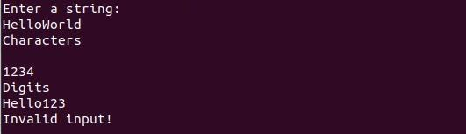

* 1. **Write a program in lex to identify tokens in a program by taking input from a file and printing the output on the terminal.**

**Code**

%{

#include<stdio.h>

%}

%%

char|int|float {printf("%s is a keyword.\n",yytext);}

[a-zA-Z][a-zA-Z0-9]* {printf("%s is an identifier.\n",yytext);}

, {printf("%s is a separator.\n",yytext);}

; {printf("%s is a delimiter.\n",yytext);}

"=" {printf("%s is an assignment operator.\n",yytext);} "+"|"-"|"*"|"/" {printf("%s is a binary operator.\n",yytext);}

[0-9]+ {printf("%s is/are digit(s).\n",yytext);}

\n ;

%%

void main()

{

yyin=fopen("input.txt","r"); yylex();

fclose(yyin);

}

int yywrap()

{

return 1;

}

**Output**

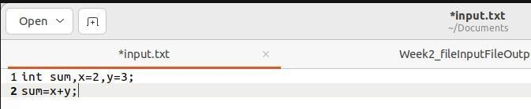

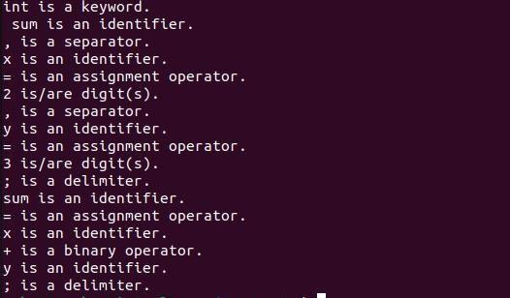

* 1. **Write a program in lex to identify tokens in a program by taking input from a file and printing the output in another file.**

**Code**

%{

#include<stdio.h>

%}

%%

char|int|float {fprintf(yyout,"%s is a keyword.\n",yytext);}

[a-zA-Z][a-zA-Z0-9]* {fprintf(yyout,"%s is an identifier.\n",yytext);}

, {fprintf(yyout,"%s is a separator.\n",yytext);}

; {fprintf(yyout,"%s is a delimiter.\n",yytext);}

"=" {fprintf(yyout,"%s is an assignment operator.\n",yytext);} "+"|"-"|"*"|"/" {fprintf(yyout,"%s is a binary operator.\n",yytext);} [0-9]+ {fprintf(yyout,"%s is/are digit(s).\n",yytext);}

\n ;

%%

void main()

{

yyin=fopen("input.txt","r"); yyout=fopen("output.txt","w"); yylex();

printf("Printed in output.txt\n"); fclose(yyin);

fclose(yyout);

}

int yywrap()

{

return 1;

}

**Output**





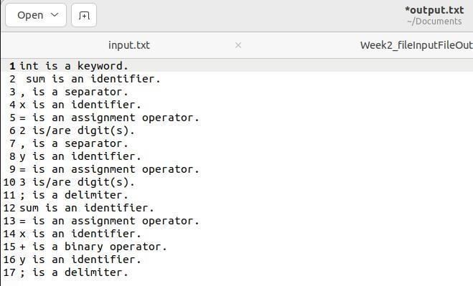

* 1. **Write a program in lex to find the length of the input string.**

**Code**

%{

#include<stdio.h>

%}

%%

[a-zA-Z0-9.,!? \t]+ {printf("Length of input string is %d.\n",yyleng);}

%%

void main()

{

printf("Enter a string:\n"); yylex();

}

int yywrap()

{

return 1;

}

**Output**

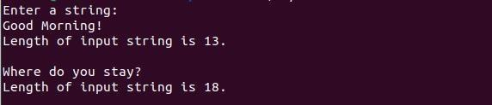

# Lab 3

* 1. **Write a program in LEX to recognize Floating Point Numbers.**

**Code**

%{

#include<stdio.h>

%}

%%

[+-]?[0-9]*[.][0-9][0-9]* {printf("Floating point number!\n");};

[+-]?[0-9][0-9]* {printf("Not a floating point number!\n");};

%%

int yywrap()

{

return 1;

}

void main()

{

printf("Enter a number:\n"); yylex();

}

**Output**

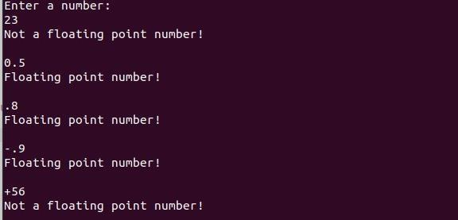

* 1. **Read and input sentence, and check if it is compound or simple. If a sentence has the word- and , or ,but ,because ,if ,then ,nevertheless then it is compound else it is simple.**

**Code**

%{

#include<stdio.h> int flag=0;

%}

%%

if|then|but|because|nevertheless|and|or {flag=1;}

. ;

\n {return 0;}

%%

int yywrap()

{

return 1;

}

void main()

{

printf("Enter a sentence:\n"); yylex();

if(flag==1)

printf("Compound sentence!\n"); else

printf("Simple sentence!\n");

}

**Output**





* 1. **Write a program to check if the input sentence ends with any of the following punctuation marks ( ? , fullstop , ! )**

**Code**

%{

#include<stdio.h> int flag=0;

%}

%%

.*[?|!|.]$ {flag=1;}

.* {flag=0;}

\n {return 0;}

%%

int yywrap()

{

return 1;

}

void main()

{

printf("Enter a sentence:\n"); yylex();

if(flag==1)

printf("Ends with a punctuation!\n"); else

printf("Does not end with punctuation!\n");

}

**Output**







* 1. **Write a program to read an input sentence and to check if the sentence begins with English articles (A, a,AN,An,THE and The).**

**Code**

%{

#include<stdio.h> int flag=0;

%}

%%

^(an|An|The|the|A|a)[" "].* {flag=1;}

.* {flag=0;}

\n {return 0;}

%%

int yywrap()

{

return 1;

}

void main()

{

printf("Enter a sentence:\n"); yylex();

if(flag==1)

printf("Starts with an article!\n"); else

printf("Does not start with an article!\n");

}

**Output**







* 1. **Lex program to count the number of comment lines (multi line comments or single line) in a program. Read the input from a file called input.txt and print the count in a file called output.txt.**

**Code**

%{

#include<stdio.h> int c=0;

%}

%%

"\/\*"[^*]*\*+([^/*][^*]*\*+)*\/ {c++;} "//".* {c++;}

. ECHO;

%%

int yywrap()

{

return 1;

}

void main()

{

yyin=fopen("input.txt","r"); yyout=fopen("output.txt","w"); yylex();

printf("The number of comments are:%d\n",c); fclose(yyin);

fclose(yyout);

}

**Output**

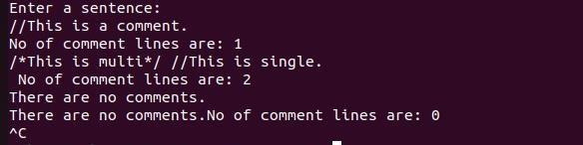

* 1. **Write a program to read and check if the user entered number is signed or unsigned using appropriate meta character.**

**Code**

%{

#include<stdio.h>

%}

%%

[+|-][0-9]+ {printf("Signed number!\n");}

[0-9]+ {printf("Unsigned number!\n");}

%%

int yywrap()

{

return 1;

}

void main()

{

printf("Enter a number:\n"); yylex();

}

**Output**

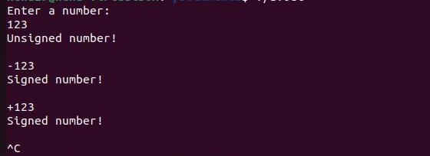

# Lab 4

* 1. **Write a LEX program that copies a file, replacing each nonempty sequence of white spaces by a single blank.**

**Code**

%{

#include<stdio.h>

%}

%%

[ \t]+ {fprintf(yyout," ");}

.|\n {fprintf(yyout,"%s",yytext);}

%%

void main()

{

yyin=fopen("text.txt","r");

yyout=fopen("print.txt","w"); yylex();

fclose(yyin); fclose(yyout); printf("Printed!\n");

}

int yywrap()

{

return 1;

}

**Output**



* 1. **Write a LEX program to recognize the following tokens over the alphabets {0,1,..,9}**
     1. **The set of all strings ending in 00.**

**Code**

%{

#include<stdio.h> int flag=0;

%}

%%

[0-9]+[00] {flag=1;}

. ;

\n {return 0;}

%%

void main()

{

printf("Enter a string:\n"); yylex();

if(flag==1)

printf("Ends with 00.\n"); else

printf("Does not end with 00.\n");

}

int yywrap()

{

return 1;

}

**Output**





* + 1. **The set of all strings with three consecutive 222’s.**

**Code**

%{

#include<stdio.h> int flag=0;

%}

%%

[0-9]*[2][2][2][0-9]* {flag=1;}

. ;

\n {return 0;}

%%

void main()

{

printf("Enter a string:\n"); yylex();

if(flag==1)

printf("Has 3 consecutive 2's.\n"); else

printf("Does not have 3 consecutive 2's.\n");

}

int yywrap()

{

return 1;

}

**Output**



* + 1. **The set of all string such that every block of five consecutive symbols contains at least two 5’s.**

**Code**

%{

#include<stdio.h> int i,count=0,flag;

%}

%%

.{1,5} {flag=0;

for(i=0;i<5;i++)

{

int c=yytext[i]-'0'; if(c==5)

{

count++; if(count==2)

{

flag=1; break;

}

}

}

count=0;

printf("yytext:%s,flag(1 if no of 5 is atleast 2):%d\n",yytext,flag); if(flag!=1)

{

printf("Not a valid string!\n"); return 0;

}

}

\n {return 0;}

%%

void main()

{

printf("Enter a string:\n"); yylex();

if(flag==1) printf("Valid string.\n");

}

int yywrap()

{

return 1;

}

**Output**

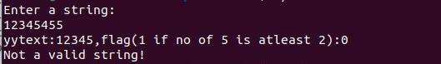

* + 1. **The set of all strings beginning with a 1 which, interpreted as the binary representation of an integer, is congruent to zero modulo 5.**

**Code**

%{

#include<stdio.h>

int c,i,flag=1,sum=0,power=1;

%}

%%

^1[01]* {for(i=yyleng-1;i>=0;i--)

{

c=yytext[i]-'0'; sum+=c*power; power*=2;

}

printf("Decimal representation:%d\n",sum); if(sum%5!=0)

{

printf("Not congruent to modulo 5.\n"); sum=0;

power=1;

}

else

{

printf("Congruent to modulo 5.\n"); sum=0;

power=1;

}

}

.* {printf("Not a binary number.\n");}

\n {return 0;}

%%

void main()

{

printf("Enter a string:\n");

yylex();

}

int yywrap()

{

return 1;

}

**Output**

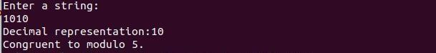

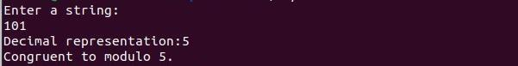

* + 1. **The set of all strings such that the 10th symbol from the right end is 1.**

**Code**

%{

#include<stdio.h> int flag=0;

%}

%%

[0-9]*1[0-9]{9} {flag=1;}

. ;

\n {return 0;}

%%

void main()

{

printf("Enter a string:\n"); yylex();

if(flag==1)

printf("10th symbol from right is 1.\n"); else

printf("10th symbol from right is not 1.\n");

}

int yywrap()

{

return 1;

}

**Output**



* + 1. **The set of all four digits numbers whose sum is 9.**

**Code**

%{

#include<stdio.h>

int sum=0,i,flag=0;

%}

%%

[0-9]{4} {for(i=0;i<yyleng;i++)

{

sum+=yytext[i]-'0';

}

if(sum==9)

{

flag=1;

sum=0;

}

else

{

flag=0;

sum=0;

}

}

\n {return 0;}

%%

void main()

{

printf("Enter a string:\n");

yylex();

if(flag==1)

printf("The sum of digits is 9.\n");

else

printf("The sum of digits is not 9.\n");

}

int yywrap()

{

return 1;

}

**Output**



* + 1. **The set of all four digital numbers, whose individual digits are in ascending order from left to right.**

**Code**

%{

#include <stdio.h>

int c,i,flag=1;

%}

%%

[0-9][0-9][0-9][0-9] {for(i=0;i<yyleng-1;i++)

{

if(yytext[i]>=yytext[i+1])

{

flag=0; break;

}

}

}

\n {return 0;}

%%

void main()

{

printf("Enter a string:\n");

yylex();

if(flag==1)

printf("The digits are in ascending order.\n");

else

printf("The digits are not in ascending order.\n");

}

int yywrap()

{

return 1;

}

**Output**





# Lab 5

**Write a C program to design lexical analysis to recognize any five keywords, identifiers, numbers, operators and punctuations.**

**Code**

#include <stdio.h>

#include <string.h>

#include <ctype.h>

void lexicalAnalyzer(char input_code[]) {

char *keywords[] = {"if", "else", "while", "for", "return"};

char *operators[] = {"+", "-", "*", "/", "=", "==", "<", ">", "<=", ">="};

char *punctuations[] = {",", ";", "(", ")", "{", "}"};

char *token = strtok(input_code, " \t\n");

while (token != NULL)

{

if (isdigit(token[0]))

{

printf("Number: %s\n", token);

}

else if (isalpha(token[0]) || token[0] == '_')

{

int isKeyword = 0;

for (int i = 0; i < sizeof(keywords) / sizeof(keywords[0]); i++)

{

if (strcmp(token, keywords[i]) == 0)

{

printf("Keyword: %s\n", token);

isKeyword = 1;

break;

}

}

if (!isKeyword)

{

printf("Identifier: %s\n", token);

}

}

else if (strchr("+-*/=<>(){}[]", token[0]) != NULL)

{

printf("Operator: %s\n", token);

}

else if(strchr(",;", token[0]) != NULL)

{

printf("Punctuation:%s\n",token);

}

token = strtok(NULL, " \t\n");

}

}

int main() {

char input_code[] = "if ( x > 0 ) { return x ; } else { return -x ; }"; lexicalAnalyzer(input_code);

return 0;

}

**Output**

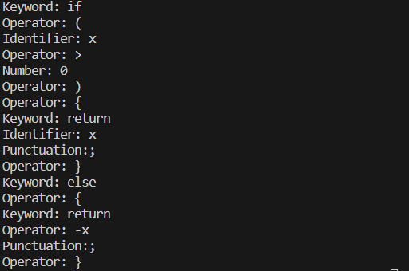

# Lab 6

**Write a program to perform recursive descent parsing on the following grammar: S->cAd**

**A->ab | a Code**

#include <stdio.h> #include<stdlib.h> char input[100]; int ind = 0;

void match(char expected)

{

if (input[ind] == expected)

{

ind++;

}

}

void A(); void S()

{

match('c'); A();

match('d');

}

void A()

{

if (input[ind] == 'a')

{

printf("Hello\n"); match('a');

match('b');

} /*else if (input[ind] == 'a')

{

printf("Hi!\n");

match('a');

}*/ else

{

printf("Parsing failed.\n", ind); exit(1);

}

}

int main() {

printf("Enter the input string:\n"); scanf("%s", input);

S();

if (input[ind] == '$') { printf("Parsing successful.\n");

} else {

printf("Parsing failed. Extra characters found.\n");

}

return 0;

}

**Output**





# Lab 7

* 1. **Write a program in YACC to design a suitable grammar for evaluation of arithmetic expression having +, -, * and /.**

**Code**

LEX

%{

#include<stdio.h> #include<stdlib.h> #include "y.tab.h" extern int yylval;

%}

%%

[0-9]+ {yylval=atoi(yytext);return num;} [\t ] ;

\n {return 0;}

. {return yytext[0];}

%%

int yywrap()

{

return 1;

}

YACC

%{

#include<stdio.h> #include<stdlib.h>

int yyerror(const char *s); int yylex(void);

%}

%token num;

%left '+' '-'

%left '*' '/'

%left ')'

%left '('

%%

s:e {printf("Valid expression!\n"); printf("Result:%d\n",$$); exit(0);

}

;

e:e'+'e {$$=$1+$3;}

|e'-'e {$$=$1-$3;}

|e'*'e {$$=$1*$3;}

|e'/'e {$$=$1/$3;}

|'('e')' {$$=$2;}

|num {$$=$1;}

;

%%

void main()

{

printf("Enter an arithmetic expression:\n"); yyparse();

}

int yyerror(const char *s)

{

printf("Invalid expression!\n"); return 0;

}

**Output**

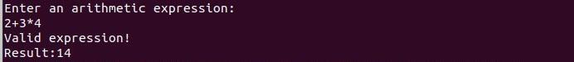

* 1. **Write a program in YACC to recognize strings of the form {(a^n)b , n>=5}.**

**Code**

LEX

%{

#include<stdio.h> #include<stdlib.h> #include "y.tab.h" extern int yylval;

%}

%%

[aA] {yylval=yytext[0];return A;} [bB] {yylval=yytext[0];return B;}

\n {return NL;}

. {return yytext[0];}

%%

int yywrap()

{

return 1;

}

YACC

%{

#include<stdio.h> #include<stdlib.h> int yyerror(char *s); int yylex(void);

%}

%token A

%token B

%token NL

%%

smtr:A A A A A S B NL {printf("Parsed using the rule (a^n)b, n>=5.\nValid String!\n");}

;

S:S A

|

;

%%

void main()

{

printf("Enter a string!\n"); yyparse();

}

int yyerror(char *s)

{

printf("Invalid String!\n"); return 0;

}

**Output**

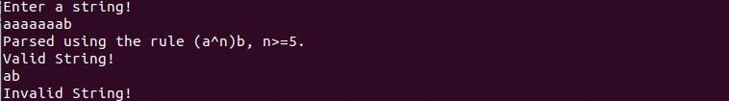

* 1. **Write a program in YACC to generate syntax tree for a given arithmetic expression. Code**

LEX

%{

#include<stdio.h> #include<stdlib.h> #include "y.tab.h" extern int yylval;

%}

%%

[0-9]+ {yylval=atoi(yytext);return digit;} [\t] ;

[\n] return 0;

. return yytext[0];

%%

int yywrap()

{

return 1;

}

YACC

%{

#include <math.h> #include<ctype.h> #include<stdio.h> #include<stdlib.h> #include<string.h> int yyerror(char *s); int yylex(void); struct tree_node

{

char val[10]; int lc;

int rc;

};

int ind;

struct tree_node syn_tree[100]; void my_print_tree(int cur_ind); int mknode(int lc,int rc,char *val);

%}

%token digit

%%

S:E {my_print_tree($1);}

;

E:E'+'T {$$=mknode($1,$3,"+");}

|T {$$=$1;}

;

T:T'*'F {$$= mknode($1,$3,"*");}

|F {$$=$1;}

;

F:'('E')' {$$=$2;}

|digit {char buf[10];sprintf(buf,"%d", yylval);$$ = mknode(-1,-1,buf);}

;

%%

int main()

{

ind=0;

printf("Enter an expression:\n"); yyparse();

return 0;

}

int yyerror(char *s)

{

printf("NITW Error\n"); return 0;

}

int mknode(int lc,int rc,char val[10])

{

strcpy(syn_tree[ind].val,val);

syn_tree[ind].lc = lc; syn_tree[ind].rc = rc; ind++;

return ind-1;

}

/*my_print_tree function to print the syntax tree in DLR fashion*/ void my_print_tree(int cur_ind)

{

if(cur_ind==-1) return;

if(syn_tree[cur_ind].lc==-1&&syn_tree[cur_ind].rc==-1)

printf("Digit Node -> Index : %d, Value : %s\n",cur_ind,syn_tree[cur_ind].val); else

printf("Operator Node -> Index : %d, Value : %s, Left Child Index : %d,Right Child Index :

%d\n",cur_ind,syn_tree[cur_ind].val, syn_tree[cur_ind].lc,syn_tree[cur_ind].rc); my_print_tree(syn_tree[cur_ind].lc);

my_print_tree(syn_tree[cur_ind].rc);

}

**Output**

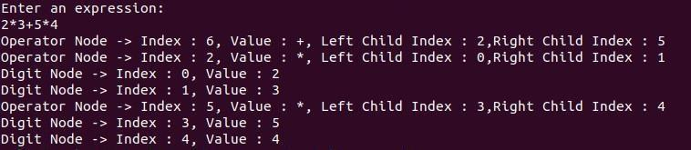

# Lab 8

**8.1Write a program in YACC to convert infix to postfix expression. Code**

LEX

%{

#include<stdio.h> #include<stdlib.h> #include "y.tab.h" extern int yylval;

%}

%%

[0-9]+ {yylval=atoi(yytext);return num;} [\t ] ;

\n {return 0;}

. {return yytext[0];}

%%

int yywrap()

{

}

YACC

%{

#include<stdio.h> #include<stdlib.h>

int yyerror(const char *s); int yylex(void);

%}

%token num

%left '+' '-'

%left '*' '/'

%left ')'

%left '('

%right '^'

%%

s:e {printf("\n");}

;

e:e'+'t {printf("+");}

|e'-'t {printf("-");}

|t

;

t:t'*'h {printf("*");}

|t'/'h {printf("/");}

|h

;

h:f'^'h {printf("^");}

|f

; f:'('e')'

|num {printf("%d",$1);}

;

%%

void main()

{

printf("Enter an infix expression:\n"); yyparse();

}

int yyerror(const char *s)

{

printf("Invalid infix expression!\n"); return 0;

}

**Output**



# Lab 9

**9.1Write a program in YACC to generate three address code for a given expression. Code**

LEX

%{

#include<stdio.h> #include<stdlib.h> #include"y.tab.h" extern int yylval; extern char iden[20];

%}

d [0-9]+

a [a-zA-Z]+

%%

{d} { yylval=atoi(yytext); return digit; }

{a} { strcpy(iden,yytext); yylval=1; return id;} [ \t] {;}

\n return 0;

. return yytext[0];

%%

int yywrap()

{

return 1;

}

YACC

%{

#include <math.h> #include<ctype.h> #include<stdio.h> int yyerror(char *s); int yylex(void);

int var_cnt=0; char iden[20];

%}

%token id

%token digit

%%

S:id '=' E {printf("%s=t%d\n",iden,var_cnt-1);}

E:E '+' T {$$=var_cnt; var_cnt++; printf("t%d = t%d + t%d;\n", $$, $1, $3 );}

|E '-' T { $$=var_cnt; var_cnt++; printf("t%d = t%d - t%d;\n", $$, $1, $3 );}

|T {$$=$1;}

;

T:T '*' F {$$=var_cnt; var_cnt++; printf("t%d = t%d * t%d;\n", $$, $1, $3 );}

|T '/' F {$$=var_cnt; var_cnt++; printf("t%d = t%d / t%d;\n", $$, $1, $3 );}

|F {$$=$1;}

;

F:P '^' F {$$=var_cnt; var_cnt++; printf("t%d = t%d ^ t%d;\n", $$, $1, $3 );}

|P {$$ = $1;}

;

P: '(' E ')' {$$=$2;}

|digit {$$=var_cnt; var_cnt++; printf("t%d = %d;\n",$$,$1);}

;

%%

int main()

{

var_cnt=0;

printf("Enter an expression:\n"); yyparse();

return 0;

}

int yyerror(char *s)

{

printf("Invalid expression!"); return 0;

}

**Output**

